Descriptive Statistics
A descriptive analysis of the data showed that there were 247 visitors who were surveyed, with more female tourists (59.1%) compared to 40.9% male tourists. The largest share (92.3%) of the visitors came into the BVI for vacation, with 4% of the tourists visiting for business purposes. A paltry 0.4% visited in search of work. Tortola Island received the majority of the visitors (59.5%) while Anegada had the least number of visitors (4.0%). Virgin Gorda had the second largest number of tourists (19.0%) while Jos Van Dyke received 7.7% of the total tourists surveyed. The remaining 9.7% of the visitors toured other parts of BVI. Arrival at the ports of entry was mainly via ferry (68.8) while arrival via air was the second largest means (23.9%). A small percentage (6.5%) of the tourists arrived via private charter. Private air and cruise ship arrivals each constituted 0.4% of all arrival means. Americans (68.4%) and Canadians (11.3%) were the majority tourists, with British visitors being a small 2.0% only. Return visitors formed a 62.3% of the total tourists surveyed, with the rest 37.7% being first time visitors. About quarter of the visitors (26.7%) had annual incomes of $200,000 and above. Only a paltry 4.0% had an income less than $20,000.
Almost half of the tourists (49.4%) were very satisfied with the destination image while those who were extremely satisfied with the destination image were equally many (40.9%). A small percentage of 1.2% was slightly satisfied with the destination image while 8.5% of the tourists were not sure about their satisfaction with destination image.
A considerably high percentage (61.5%) of the tourists were extremely satisfied while 36.8% of the tourists were very satisfied. Only a very small percentage (0.4%) of the visitors were slightly satisfied. Those who were unsure about their satisfied also formed a small percentage of 1.2%.
Gender
 |  | Frequency | Percent | Valid Percent | Cumulative Percent
Valid | Male | 101 | 40.9 | 40.9 | 40.9
Valid | Female | 146 | 59.1 | 59.1 | 100.0
Valid | Total | 247 | 100.0 | 100.0

Purpose
 |  | Frequency | Percent | Valid Percent | Cumulative Percent
Valid | Vacation | 228 | 92.3 | 92.3 | 92.3
Valid | Business | 10 | 4.0 | 4.0 | 96.4
Valid | Seeking Work | 1 | .4 | .4 | 96.8
Valid | Other | 8 | 3.2 | 3.2 | 100.0
Valid | Total | 247 | 100.0 | 100.0

Island
 |  | Frequency | Percent | Valid Percent | Cumulative Percent
Valid | Tortola | 147 | 59.5 | 59.5 | 59.5
Valid | Virgin Gorda | 47 | 19.0 | 19.0 | 78.5
Valid | Anegada | 10 | 4.0 | 4.0 | 82.6
Valid | Jost Van Dkye | 19 | 7.7 | 7.7 | 90.3
Valid | Other | 24 | 9.7 | 9.7 | 100.0
Valid | Total | 247 | 100.0 | 100.0

Arrive
 |  | Frequency | Percent | Valid Percent | Cumulative Percent
Valid | Air | 59 | 23.9 | 23.9 | 23.9
Valid | Private Air | 1 | .4 | .4 | 24.3
Valid | Cruise Ship | 1 | .4 | .4 | 24.7
Valid | Ferry | 170 | 68.8 | 68.8 | 93.5
Valid | Private Charter | 16 | 6.5 | 6.5 | 100.0
Valid | Total | 247 | 100.0 | 100.0

Nationality
 |  | Frequency | Percent | Valid Percent | Cumulative Percent
Valid | America | 26 | 10.5 | 10.5 | 10.5
Valid | American | 169 | 68.4 | 68.4 | 78.9
Valid | Antiguan | 1 | .4 | .4 | 79.4
Valid | Argentinian | 2 | .8 | .8 | 80.2
Valid | British | 5 | 2.0 | 2.0 | 82.2
Valid | Canada | 2 | .8 | .8 | 83.0
Valid | Canadian | 28 | 11.3 | 11.3 | 94.3
Valid | Chinese | 1 | .4 | .4 | 94.7
Valid | Dominican | 1 | .4 | .4 | 95.1
Valid | German | 1 | .4 | .4 | 95.5
Valid | Irish | 1 | .4 | .4 | 96.0
Valid | Italy | 1 | .4 | .4 | 96.4
Valid | Kittitian | 1 | .4 | .4 | 96.8
Valid | New Zealand | 2 | .8 | .8 | 97.6
Valid | Nicaragua | 1 | .4 | .4 | 98.0
Valid | Swedish | 4 | 1.6 | 1.6 | 99.6
Valid | UK | 1 | .4 | .4 | 100.0
Valid | Total | 247 | 100.0 | 100.0

Visted_Before
 |  | Frequency | Percent | Valid Percent | Cumulative Percent
Valid | Yes | 154 | 62.3 | 62.3 | 62.3
Valid | No | 93 | 37.7 | 37.7 | 100.0
Valid | Total | 247 | 100.0 | 100.0

Income
 |  | Frequency | Percent | Valid Percent | Cumulative Percent
Valid | Less than $20,000 | 10 | 4.0 | 4.0 | 4.0
Valid | $20,000-$39.999 | 10 | 4.0 | 4.0 | 8.1
Valid | $40,000-$59,000 | 34 | 13.8 | 13.8 | 21.9
Valid | $60,000-$79,999 | 27 | 10.9 | 10.9 | 32.8
Valid | $80,000-$99.999 | 40 | 16.2 | 16.2 | 49.0
Valid | $100,000-$149,999 | 32 | 13.0 | 13.0 | 61.9
Valid | $150,000-$199,999 | 28 | 11.3 | 11.3 | 73.3
Valid | Above $200,000 | 66 | 26.7 | 26.7 | 100.0
Valid | Total | 247 | 100.0 | 100.0

Destination Image
 |  | Frequency | Percent | Valid Percent | Cumulative Percent
Valid | Slightly Satisfied | 3 | 1.2 | 1.2 | 1.2
Valid | Unsure | 21 | 8.5 | 8.5 | 9.7
Valid | Very Satisfied | 122 | 49.4 | 49.4 | 59.1
Valid | Extremely Satisfied | 101 | 40.9 | 40.9 | 100.0
Valid | Total | 247 | 100.0 | 100.0

Descriptives

Descriptive Statistics
 | N | Minimum | Maximum | Mean | Std. Deviation
Push1 | 247 | 1.00 | 5.00 | 4.0081 | .81646
Push2 | 247 | 2.00 | 5.00 | 4.2753 | .63528
Push3 | 247 | 1.00 | 5.00 | 4.1903 | .71014
Push4 | 247 | 1.00 | 5.00 | 4.2713 | .71802
Push5 | 247 | 1.00 | 5.00 | 3.8623 | .92244
Valid N (listwise) | 247

Descriptive Statistics
 | N | Minimum | Maximum | Mean | Std. Deviation
Push6 | 247 | 1.00 | 5.00 | 3.9514 | .85401
Push7 | 247 | 1.00 | 5.00 | 3.8057 | 1.04895
Push8 | 247 | 1.00 | 5.00 | 3.7206 | 1.07015
Push9 | 247 | 1.00 | 5.00 | 3.7976 | 1.02782
Valid N (listwise) | 247

Descriptive Statistics
 | N | Minimum | Maximum | Mean | Std. Deviation
Push10 | 247 | 1.00 | 5.00 | 4.1093 | .86497
Push11 | 247 | 1.00 | 5.00 | 4.2794 | .74278
Push12 | 247 | 1.00 | 5.00 | 4.1053 | .91346
Push13 | 247 | 1.00 | 5.00 | 4.0405 | .92744
Valid N (listwise) | 247

Descriptive Statistics
 | N | Minimum | Maximum | Mean | Std. Deviation
Push14 | 247 | 1.00 | 5.00 | 4.0891 | .95857
Push15 | 247 | 1.00 | 5.00 | 4.2186 | .88390
Push16 | 247 | 1.00 | 5.00 | 4.1012 | .94669
Push17 | 247 | 2.00 | 5.00 | 4.3887 | .68280
Valid N (listwise) | 247

Descriptive Statistics
 | N | Minimum | Maximum | Mean | Std. Deviation
Push18 | 247 | 1.00 | 5.00 | 4.1215 | .88886
Push19 | 247 | 1.00 | 5.00 | 3.6356 | 1.11020
Push20 | 247 | 1.00 | 5.00 | 3.6802 | 1.16125
Push21 | 247 | 1.00 | 5.00 | 3.7166 | 1.18281
Valid N (listwise) | 247

Descriptive Statistics
 | N | Minimum | Maximum | Mean | Std. Deviation
Push22 | 247 | 1.00 | 5.00 | 3.6356 | 1.24484
Push23 | 247 | 1.00 | 5.00 | 3.8016 | 1.10667
Push24 | 247 | 1.00 | 5.00 | 3.4737 | 1.18180
Push25 | 247 | 1.00 | 5.00 | 3.7449 | 1.11335
Valid N (listwise) | 247

Descriptive Statistics
 | N | Minimum | Maximum | Mean | Std. Deviation
Pull1 | 247 | 1.00 | 5.00 | 3.8340 | .98401
Pull2 | 247 | 1.00 | 5.00 | 3.4858 | .99122
Valid N (listwise) | 247

Descriptive Statistics
 | N | Minimum | Maximum | Mean | Std. Deviation
Pull3 | 247 | 1.00 | 5.00 | 3.8583 | .92841
Pull4 | 247 | 1.00 | 5.00 | 3.7854 | 1.02732
Pull5 | 247 | 1.00 | 5.00 | 3.7814 | 1.00849
Valid N (listwise) | 247

Descriptive Statistics
 | N | Minimum | Maximum | Mean | Std. Deviation
Pull6 | 247 | 1.00 | 5.00 | 3.9190 | .99262
Pull7 | 247 | 1.00 | 5.00 | 3.6559 | .98721
Valid N (listwise) | 247

Descriptive Statistics
 | N | Minimum | Maximum | Mean | Std. Deviation
Pull8 | 247 | 1.00 | 5.00 | 3.8219 | .96306
Pull9 | 247 | 2.00 | 5.00 | 4.3482 | .82160
Valid N (listwise) | 247

Descriptive Statistics
 | N | Minimum | Maximum | Mean | Std. Deviation
Pull10 | 247 | 1.00 | 5.00 | 4.2186 | .82687
Valid N (listwise) | 247

Descriptive Statistics
 | N | Minimum | Maximum | Mean | Std. Deviation
Pull11 | 247 | 2.00 | 5.00 | 4.4251 | .72236
Valid N (listwise) | 247

Descriptive Statistics
 | N | Minimum | Maximum | Mean | Std. Deviation
Pull12 | 247 | 2.00 | 5.00 | 4.5870 | .67438
Valid N (listwise) | 247

Descriptive Statistics
 | N | Minimum | Maximum | Mean | Std. Deviation
Pull12 | 247 | 2.00 | 5.00 | 4.5870 | .67438
Valid N (listwise) | 247

Tourist Satisfaction
 |  | Frequency | Percent | Valid Percent | Cumulative Percent
Valid | Slightly Satisfied | 1 | .4 | .4 | .4
Valid | Unsure | 3 | 1.2 | 1.2 | 1.6
Valid | Very Satisfied | 91 | 36.8 | 36.8 | 38.5
Valid | Extremely Satisfied | 152 | 61.5 | 61.5 | 100.0
Valid | Total | 247 | 100.0 | 100.0

Reliability Test

Chronbach’s Alpha
A Cronbach’s alpha test indicated that the push motives subscale consisted of 25 items (α= .927) while the pull motives subscale had 12 items (α = .869). Therefore, the questionnaire was found to be highly reliable.

Push motives

Reliability Statistics
Cronbach's Alpha | N of Items
.927 | 25

Item-Total Statistics
 | Scale Mean if Item Deleted | Scale Variance if Item Deleted | Corrected Item-Total Correlation | Cronbach's Alpha if Item Deleted
Push1 | 95.0162 | 198.943 | .501 | .925
Push2 | 94.7490 | 201.026 | .539 | .925
Push3 | 94.8340 | 200.456 | .507 | .925
Push4 | 94.7530 | 197.699 | .640 | .924
Push5 | 95.1619 | 196.461 | .535 | .925
Push6 | 95.0729 | 198.783 | .483 | .925
Push7 | 95.2186 | 190.318 | .682 | .922
Push8 | 95.3036 | 190.359 | .665 | .923
Push9 | 95.2267 | 192.891 | .602 | .924
Push10 | 94.9150 | 196.623 | .568 | .924
Push11 | 94.7449 | 198.646 | .571 | .924
Push12 | 94.9190 | 193.766 | .651 | .923
Push13 | 94.9838 | 196.170 | .543 | .925
Push14 | 94.9352 | 200.272 | .367 | .927
Push15 | 94.8057 | 198.092 | .493 | .925
Push16 | 94.9231 | 197.364 | .484 | .926
Push17 | 94.6356 | 201.216 | .489 | .926
Push18 | 94.9028 | 194.714 | .631 | .923
Push19 | 95.3887 | 190.076 | .648 | .923
Push20 | 95.3441 | 189.568 | .633 | .923
Push21 | 95.3077 | 190.157 | .601 | .924
Push22 | 95.3887 | 192.491 | .495 | .926
Push23 | 95.2227 | 192.092 | .581 | .924
Push24 | 95.5506 | 190.940 | .576 | .924
Push25 | 95.2794 | 190.438 | .634 | .923

Pull motives

Reliability Statistics
Cronbach's Alpha | N of Items
.869 | 12

Item-Total Statistics
 | Scale Mean if Item Deleted | Scale Variance if Item Deleted | Corrected Item-Total Correlation | Cronbach's Alpha if Item Deleted
Pull1 | 43.8866 | 41.711 | .544 | .859
Pull2 | 44.2348 | 42.278 | .491 | .863
Pull3 | 43.8623 | 40.615 | .686 | .850
Pull4 | 43.9352 | 39.671 | .685 | .849
Pull5 | 43.9393 | 39.919 | .679 | .849
Pull6 | 43.8016 | 41.550 | .551 | .858
Pull7 | 44.0648 | 41.654 | .546 | .859
Pull8 | 43.8988 | 41.498 | .578 | .857
Pull9 | 43.3725 | 43.381 | .512 | .861
Pull10 | 43.5020 | 43.023 | .543 | .859
Pull11 | 43.2955 | 45.469 | .370 | .868
Pull12 | 43.1336 | 45.263 | .427 | .865

Assumptions Tests
A sample size of 247 was sufficient to realize a power of above 0.99. The Shapiro-Wilk test of normality indicated that the data significantly deviated from normal distribution; Destination image and tourism satisfaction, p <.001 each while push motives and pull motives Shapiro-Wilk test was significant, p= 0.003 and 0.002 respectively.
The histogram showed a distribution of data that was not normal as some data was skewed on the far left while some data points were exceptionally higher in frequency than the rest. The scatter plot of residual versus predicted values also showed lack of linearity in the data as there were outliers and most data points were on the negative side of the regression line. The Normal P-P plot also indicated that the data was not linear as the data points were straying from the diagonal line in a non-linear manner. Autocorrelation was ruled out as the Durbin-Watson value was 1.864, which is clearly above 1.4 and within the acceptable range of 1.5-2.5.
Multicollinearity in the data was ruled out because the VIF values of the independent variables were between 1 and 10, i.e. 1.113 while the tolerance values were above 0.2, i.e. 0.899. Moreover, both condition indices were below a value of 30 (14.09 and 18.225 for destination image and push and pull motives respectively), meaning the data was less likely collinear.

Tests of Normality
 | Kolmogorov-Smirnovª |  |  | Shapiro-Wilk
 | Statistic | df | Sig. | Statistic | df | Sig.
Destination Image | .263 | 247 | .000 | .774 | 247 | .000
Tourist Satisfaction | .389 | 247 | .000 | .653 | 247 | .000
Push motives | .061 | 247 | .025 | .982 | 247 | .003
Pull motives | .075 | 247 | .002 | .980 | 247 | .002
a. Lilliefors Significance Correction

Collinearity Diagnosticsª
Model | Dimension | Eigenvalue | Condition Index | Variance Proportions
 |  |  |  | (Constant) | NewDestImage | Push and Pull motives
1 | 1 | 2.976 | 1.000 | .00 | .00 | .00
1 | 2 | .015 | 14.098 | .04 | .90 | .36
1 | 3 | .009 | 18.225 | .95 | .10 | .63
a. Dependent Variable: NewTouristSat

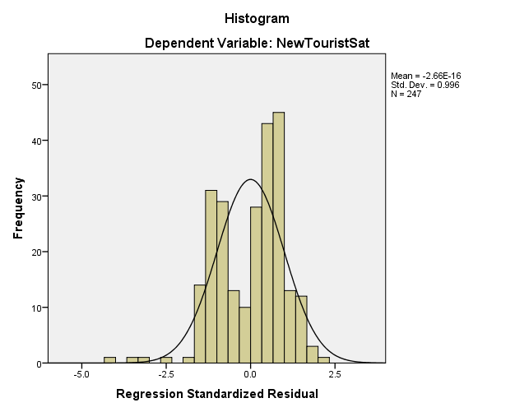

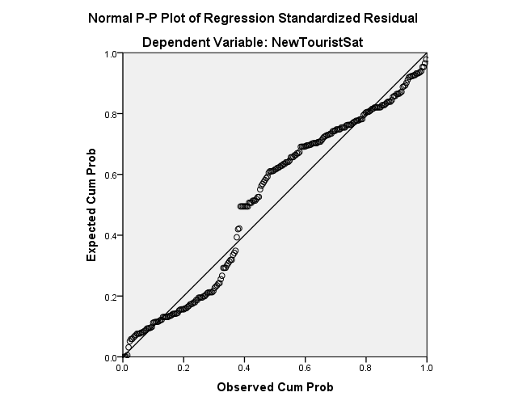

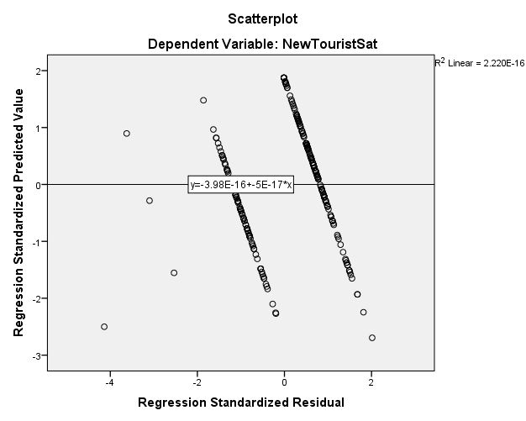

Inferential Statistics
Following the violation of the linearity and normality assumptions, bootstrapping employed for 247 samples at 95% confidence interval to see whether there were possible influences of the violation of assumption.
Following the violation of the linearity and normality assumptions, bootstrapping procedures were employed to see whether there were possible influences of the violation of assumption.
A multiple regression analysis was conducted to determine whether there was a relationship between destination image, push and pull motives to travel, and BVI tourists' satisfaction. The hypotheses were:
H1₀: There is no statistically significant relationship between destination image, push and pull motives to travel, and BVI tourists’ satisfaction.
H1a: There is a statistically significant relationship between destination image, push and pull motives to travel, and BVI tourists’ satisfaction.
The results of the regression indicated that the two predictors, destination image and push and pull motives to travel, explained 16.6% of the variance in tourist satisfaction (R²= .166, F(2,244)= 24.233, p<.001). It was evident that destination image significantly predicted tourist satisfaction (β=.168, p=.001), as did push and pull motives (β = .190, p<.001). The bootstraps for push and pull motives and new destination image were still significant (p=.004), meaning that the two independent variables were statistically significant predictors of tourist satisfaction.
The null hypothesis was rejected as there was a statistically significant relationship between destination image, push, and pull motives to travel and BVI tourists' satisfaction.

Model Summary^{b}
Model | R | R Square | Adjusted R Square | Std. Error of the Estimate | Change Statistics |  |  |  |  | Durbin-Watson
 |  |  |  |  | R Square Change | F Change | df1 | df2 | Sig. F Change | Durbin-Watson
1 | .407ª | .166 | .159 | .49449 | .166 | 24.233 | 2 | 244 | .000 | 1.864
a. Predictors: (Constant), NewDestImage, Push and Pull motives
b. Dependent Variable: NewTouristSat

Bootstrap for Model Summary
Model | Durbin-Watson | Bootstrapª
Model | Durbin-Watson | Bias | Std. Error | 95% Confidence Interval
 |  |  |  | Lower | Upper
1 | 1.864 | -.666 | .125 | .960 | 1.414
a. Unless otherwise noted, bootstrap results are based on 247 bootstrap samples

ANOVAª
Model |  | Sum of Squares | df | Mean Square | F | Sig.
1 | Regression | 11.851 | 2 | 5.925 | 24.233 | .000^{b}
1 | Residual | 59.663 | 244 | .245
1 | Total | 71.514 | 246
a. Dependent Variable: NewTouristSat
b. Predictors: (Constant), NewDestImage, Push and Pull motives

Coefficientsª
Model |  | Unstandardized Coefficients |  | Standardized Coefficients | t | Sig. | Collinearity Statistics
 |  | B | Std. Error | Beta | t | Sig. | Tolerance | VIF
1 | (Constant) | 2.746 | .268 |  | 10.263 | .000
1 | Push and Pull motives | .190 | .041 | .289 | 4.678 | .000 | .899 | 1.113
1 | NewDestImage | .168 | .049 | .210 | 3.399 | .001 | .899 | 1.113
a. Dependent Variable: NewTouristSat

Bootstrap for Coefficients
Model |  | B | Bootstrapª
 |  | B | Bias | Std. Error | Sig. (2-tailed) | 95% Confidence Interval
 |  |  |  |  |  | Lower | Upper
1 | (Constant) | 2.746 | -.014 | .297 | .004 | 2.100 | 3.254
1 | Push and Pull motives | .190 | .002 | .049 | .004 | .097 | .289
1 | NewDestImage | .168 | -.001 | .053 | .004 | .049 | .269
a. Unless otherwise noted, bootstrap results are based on 247 bootstrap samples

